Automagically tagging content items using Artificial Vision and Artificial Intelligence

# Introduction

Nowadays Artificial Vision and Artificial Intelligence has become more and more accessible to everybody thank to public API as [Azure Computer Vision API](https://azure.microsoft.com/en-us/services/cognitive-services/computer-vision/). It provides huge value to automatically classify and organize content helping organization to provide more value to their customers and users. Liquid Content provides a great flexible API to easily integrate with these technologies increasing the value of your content.

In order to show how this can be achieved we have created a simple integration with Azure Computer Vision API.

# Use case

Now let’s image the following use case. As a **Content Manager** of a big company with images submitted daily by Content Editors, I want to improve the process of content item tagging and description taking benefit of Artificial Intelligence and Artificial Vision. To organize those Images we use Liquid Content and each image is mapped to a Content Item. Content Editors adds new images from the Content Library and those are displayed in our website in a gallery page.

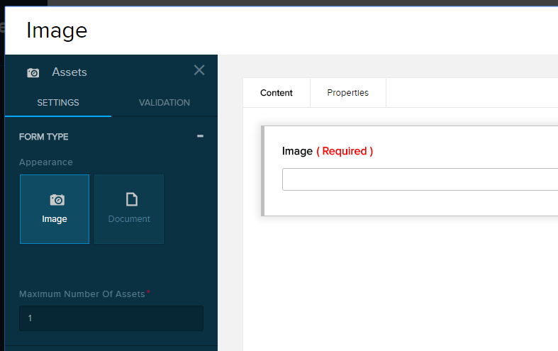

Image Content Type

**The goal** is to automate the **creation of tags and description** on content item publication analyzing the image associated to it.

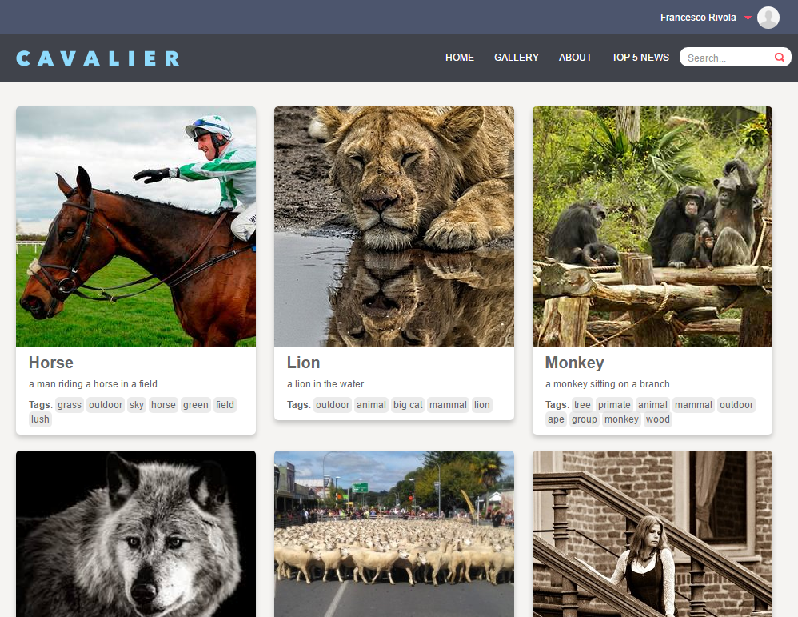

Gallery of images with description and tags generated automatically using AI

# Solution

Liquid Content provides two ways API:

1. PULL information: create or read data on demand via http **Web API**
2. PUSH information: it allows you to subscribe to one or more events and receive a **Web Hook** notification via http.

To achieve our goal we will structure our application in the following 4 steps:

1. subscribe to the Content Item Creation Event of Content Items of the specific Content Type (our Image Content Type)
2. when notified we will read the content item, get the main image field
3. we will send the image to Azure Computer Vision API to get tags and caption information
4. finally we will update the content item adding the obtained metadata to the tags and description fields

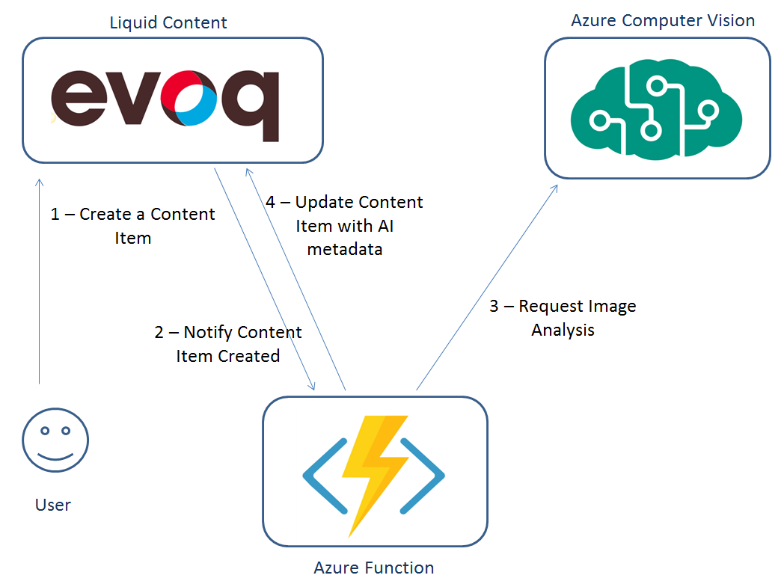

Are you interested in knowing more about how Liquid Content can be used to achieve AI Integration? Please follow [this link](https://github.com/dnnsoftware/Dnn.Evoq.LiquidContent.Samples/tree/master/Francesco/AutoTaggingContentItems) for more all the full solution code and documentation step by step to how implement your own integration. Have fun!!